**LAB : 2**

**OBJECTIVE :**

1. Study Use case diagrams to answer given situaton.
2. Draw Use Case diagram for Ticket Distributor for a Train System

**Requrements :**

(a) Windows PC (Windows 7/8/10) / Mac

(b) Star UML Tool

**Procedure :**

1. **Study Use case diagrams to answer given situaton**

**2-1 Consider an ATM system. Identify at least three different actors that interact with this system.**

An actor is any entity (user or system) that interacts with the system of interest. For an ATM, possible actors are :

• Bank Customer

•ATM Maintainer

• Central Bank Computer

**2–2 Can the system under consideration be represented as an actor? Justify your answer.**

The system under consideration is not external to the system and shouldn’t be represented as an actor. There are a few cases, however, when representing the system as an actor may clarify the use case model. These include situations where the system initiates uses cases, for example, as time passes (Check for Outdated Articles, Send Daily Newsletter).

**2–3 What is the difference between a scenario and a use case? When do you use each construct?**

A **scenario** is an actual sequence of interactions (i.e., an instance) describing one speciﬁc situation; a use case is a general sequence of interactions (i.e., a class) describing all possible scenarios associated with a situation. Scenarios are used as examples and for clarifying details with the client.

**Use cases** are used as complete descriptions to specify a user task or a set of related system features.

1. **Draw Use Case diagram for Ticket Distributor for a Train System**

**Problem Statement :**

Draw a use case diagram for a ticket distributor for a train system. The system includes two actors: a traveler,who purchases different types of tickets, and a central computer system, which maintains a reference database for the tariff.

Use cases should include: BuyOneWayTicket, BuyWeeklyCard, BuyMonthlyCard, UpdateTariff. Also include the following exceptional cases: Time-Out (i.e., traveler took too long to insert the right amount), TransactionAborted (i.e., traveler selected the cancel button without completing the transaction), DistributorOutOfChange, and DistributorOutOfPaper

**Use Case Diagram :**

1. The traveler (actor) decides which kind of ticket he wants to buy, one way, weekly or monthly card.
2. Further user can face the exceptions like time runs out or transaction gets aborted in between or distributor gets out of change.
3. The relationship between the exceptional use cases and normal use cases uses <> relationship, as extend is used to extend the use cases in order to add new functionality in the use cases.
4. On the other side, CentralComputerSystem will see the function of UpdateTariff.

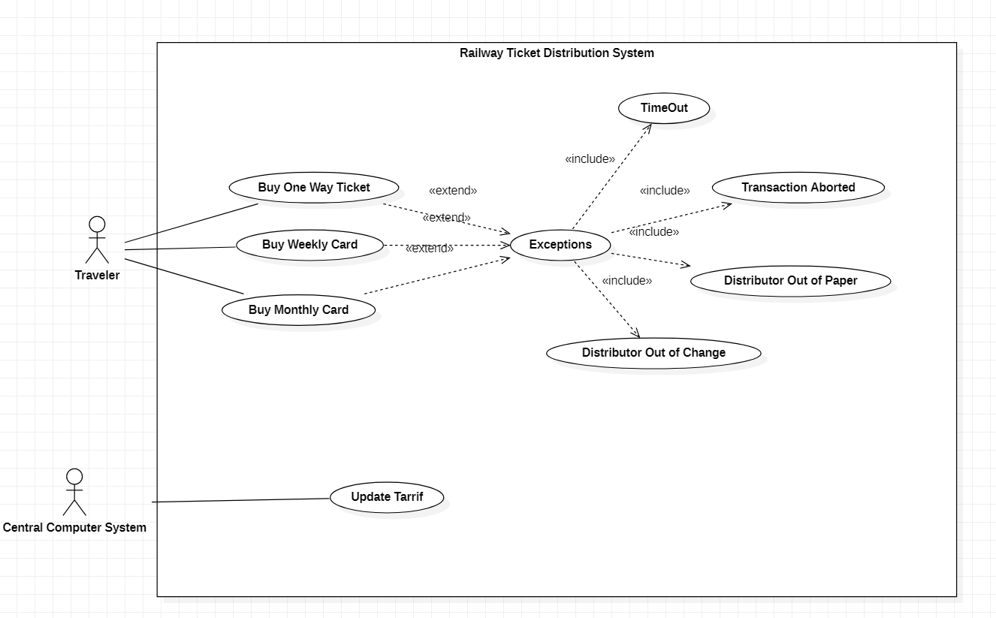

**Fig 2.1** Use case diagram for a ticket distributor